**A**

**MINI PROJECT REPORT**

**on**

**“Know The Trend”**

**BE(AI&DS)-IV Sem**

**By**

**Kushal Rathi(160120747034)**

**Rithvik Ramdas(160120747043)**

**Under the guidance of**

**Dr. Pragati Priyadarshinee**

**Assistant Professor**

**IT Department , CBIT**



**DEPARTMENT OF INFORMATION TECHNOLOGY CHAITANYA BHARATHI INSTITUTE OF TECHNOLOGY (A)**

**(Affiliated to Osmania University; Accredited by NBA(AICTE) and NAAC(UGC), ISO Certified 9001:2015)**

**KOKAPET(V), GANDIPET(M), RR District HYDERABAD - 75**

**Website:** [**www.cbit.ac.in**](http://www.cbit.ac.in/)

**2021-2022**



This is to certify that the project work entitled “**Know The Trend**” submitted to CHAITANYA BHARATHI INSTITUTE OF TECHNOLOGY, in partial fulfillment of the requirements for the award of the completion of IV Semester of B.E. in Artificial Intelligence and Data Science, during the Academic Year 2021-2022, is a record of original work done by **Kushal Rathi(160120747034) and Rithvik Ramdas(160120747043)** during the period of study in the Department of IT, CBIT, HYDERABAD, under our guidance.

|  |  |
| --- | --- |
| **Project Guide** | **Head of the Department** |
| **Dr Pragati Priyadarshinee** | **Dr K. Radhika** |
| Assistant Professor, Dept. of IT, | Professor, Dept. of IT, |
| CBIT, Hyderabad. | CBIT, Hyderabad. |

## ACKNOWLEDGEMENT

We would like to express our heartfelt gratitude to **Dr D. L. Sreenivasa Reddy** our project guide, for her invaluable guidance and constant support, along with her capable instruction and persistent encouragement.

We are grateful to our Head of Department, **Dr K. Radhika**, for her steady support and for the provision of every resource required for the completion of this project.

We would like to take this opportunity to thank our Principal, **Dr P. Ravinder Reddy**, as well as the Management of the Institute, for having designed an excellent learning atmosphere.

Our thanks are due to all members of the staff and our lab assistants for providing us with the help required to carry out the groundwork of this project.

**CONTENTS**

|  |  |  |
| --- | --- | --- |
| **S.No** | **Topics** | **Page. No** |
|  | **List of Figures**  **Abbreviations**  **Abstract** | 6  6  7 |
| 1 | **Introduction** |  |
| * 1. Motivation | 8 |
| * 1. Objective of the Project | 8 |
| 1.3 Problem Statement | 8 |
| 2 | **Existing System** |  |
| 2.1 Literature survey | 10 |
| 3 | **Proposed Methodology** |  |
| 3.1 System Specifications | 12 |
| 3.2 System Design | 12 |
| 3.3 Proposed Work | 13 |
| 4 | **Implementation of Project and Results** | 14 |
| 5 | **Conclusion and Future Scope** | 32 |
| 6 | **Bibliography** | 33 |

## 

**List of Figures**

|  |  |  |
| --- | --- | --- |
| **S** no. | **Name of figure** | **Page no.** |
| **1** | **Market sector** | **8** |
| **2** | **Motilal oswal app** | **9** |
| **3** | **Money control app** | **10** |
| **4** | **Project implementation pictures** |  |
|  |  |  |

**List of Abbreviations**

|  |  |
| --- | --- |
| **Acronym** | **Abbreviation** |
| **HTML** | **Hypertext Markup Language** |
| **CSS** | **Cascading Style Sheets** |
| **JS** | **Java Script** |
| **BSE** | **Bombay Stock Exchange** |
| **NSE** | **National Stock Exchange** |
| **MOSL** | **Motilal Oswal Securities Limited** |
| **IPO** | **Initial Public Offering** |

# 

#### ABSTRACT

Stock market involves a lot of risks, where people invest huge amounts of money without proper knowledge and information. Strategies play a key role in the stock markets to gain huge profits, as the value of markets changes from time to time it is important to keep track of the investments as well.

Stocks is one of the trending topics these days, which basically involves investment of money in one of the top companies based on their IPO’s, market value etc. Without proper knowledge about stock markets and the way it works, people may lose crores of money. So, the point which motivated to work on this project giving tips to the people on when to invest, how to invest and also include the stocks of some of the top companies in terms of share value etc. We wanted to develop a website based on the above idea so that we could reach out to every person possible, and websites do not have any restrictions like “works only in respective operating systems”.

So through our website we are going to give tips regarding investment like important terms regarding investments, share values of the company, IPO’S, strategies etc. So this information might help people to invest money in the right stock.

# 

#### 1.INTRODUCTION

#### Motivation:

“Earlier people used to wait outside BSE (Bombay Stock Exchange) to check for market prices and find out about the stocks. But now with invention of mobile phones and laptops people can access information related to stocks from anywhere.

Also after covid pandemic many businesses have been affected and the stock market has aroused interest in the many youngsters and people, as their way to earn in crisis and also become financial independent. It is not to tough to understand the stock market and once a person learns basics on investing he can find his way through the market.”

# Problem Statement:

“The youth nowadays looks up to the stock market as a resource for them to start their side income but with no proper knowledge and also no history of stocks provided they find it difficult to make their way through the stock market.”

# Objective of our Project:

“Through our website we aim at giving knowledge to the beginners about some of the stocks that have been performing well in various sectors and also provide them with some useful tips so that they would be clear about when to invest and when to sell.”

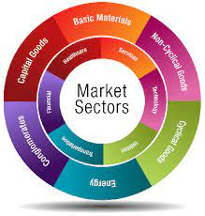

Fig1: Market Sectors

#### 

#### 2. EXISTING SYSTEMS

#### Literature Survey

There are many famous websites for stocks like BSE, NSE, Money control and Motilal Oswal. These websites give information about stocks and also allow users to create demat account so that they can perform live trading. In their websites they provide history of stocks, increase and decrease of market.

Motilal Oswal Securities Ltd (MOSL) is a Mumbai based broker company offering stock, commodity and currency trading services to retail customers in India. MOSL is part of Motilal Oswal Group, a diversified financial service provider in India offering services including broking, loans, investment banking, wealth management etc.

Motilal Oswal is a **full-service broker** offering its services through a network of over 2200+ branches and sub brokers in over 500 cities in India.



Fig 2: Motilal oswal app

Money Control helps **users to maintain a customised watchlist that will contain all of their favourite financial products**. One can stay updated with all the latest news about their favourite stocks through this watchlist, and this will help them in taking better investment decisions.



Fig 3: Money control app

#### 

#### 3. PROPOSED METHODOLOGY

#### System specifications

Software Requirements

* Operating system: Windows7/8/10
* Tools: Visual studio code
* Front end:

HTML: It is the code that is used to structure a web page and its contents.

CSS: It is a style sheet used for describing the presentation of a document written in

a markup language such as HTML. It creates an attractive layout.

JavaScript: JavaScript is a text-based programming language used both on the client-

side and server-side that allows us to make web pages interactive.It creates a dynamic and interactive experience for the user.

Hardware Requirements

* Processor: Intel Pentium
* Processor Speed: 1.5 GHz
* RAM: 2GB or above
* Hard Disk: 50 GB or above

#### 

#### SYSTEM DESIGN

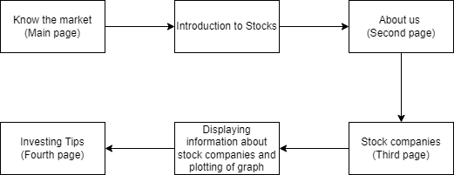

#### 

#### 

Fig 4: System design

#### 

#### 

#### Proposed Work

1. Selection of idea (Stocks)

2. Gathering of information related to stock companies

3. Knowledge about selected stock companies

4. Deciding the requirements for developing the website (HTML, CSS and JAVASCRIPT)

5. Starting with HTML

6. After learning the basic part of HTML, we started with design of our website

7. Gathering images related to selected companies and adding them to our website

8. Continuing with HTML and further design

9. Through JAVASCRIPT, gathering data and plotting graphs for selected companies

10. Starting with CSS

11. Styling our website with CSS and aligning the images and headings

12. Final testing of our website and debugging

13. Website created.

# 

#### 4. IMPLEMENTATION AND RESULTS

**Home Page Design**

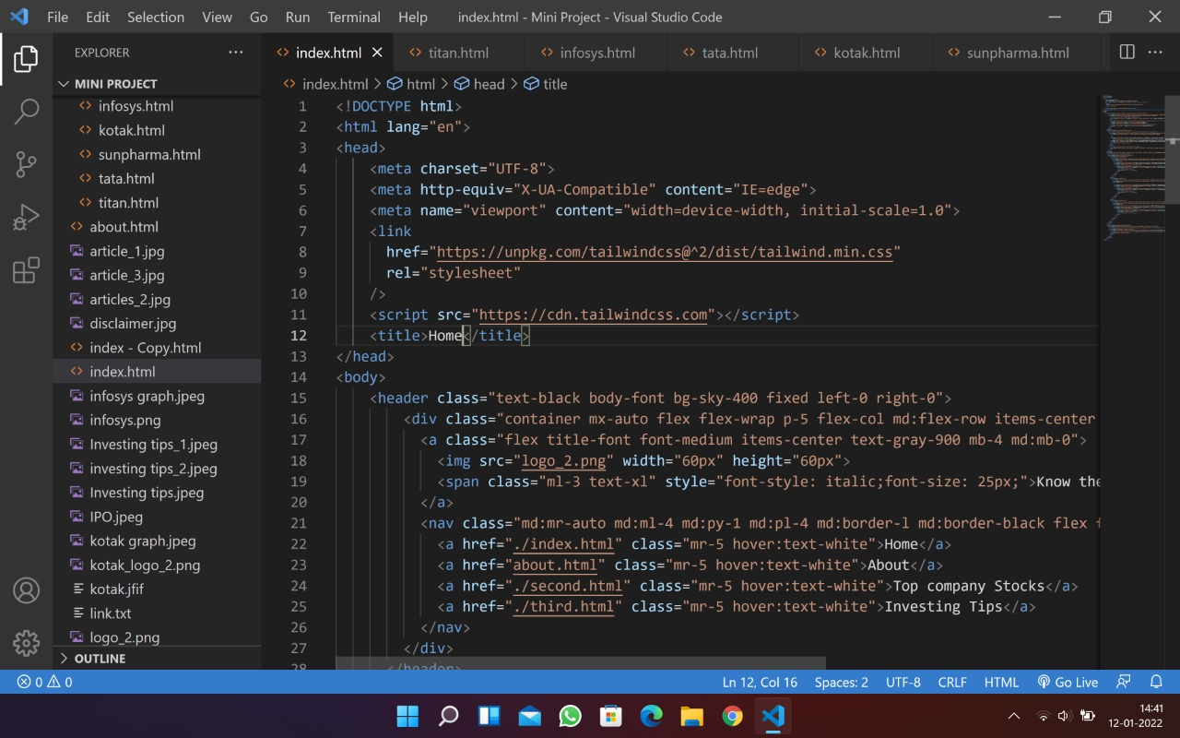

Fig 4.1: Home page code

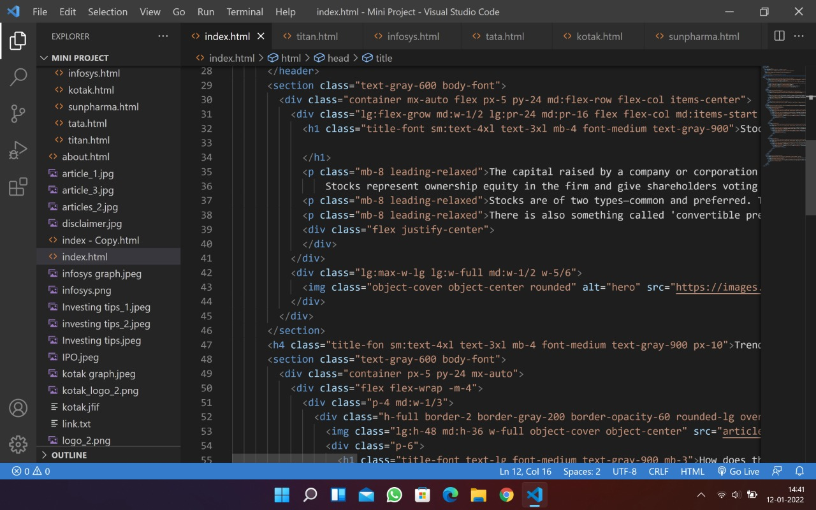

Fig 4.2: Home page code part 2

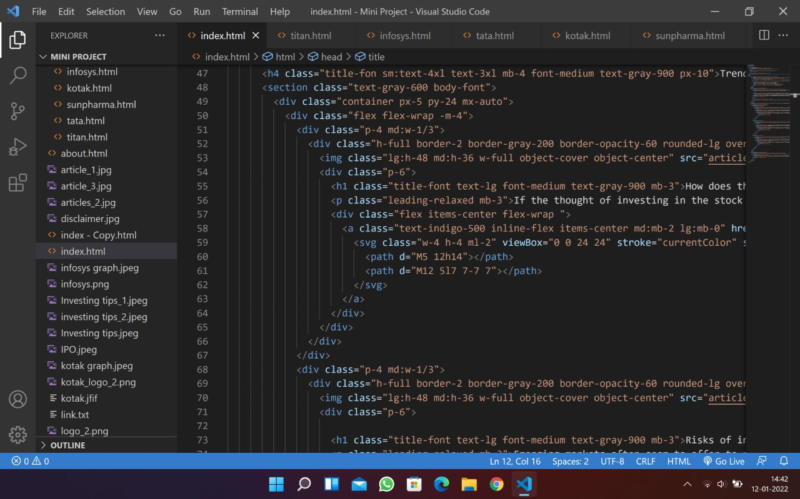

Fig 4.3: Home page code part 3

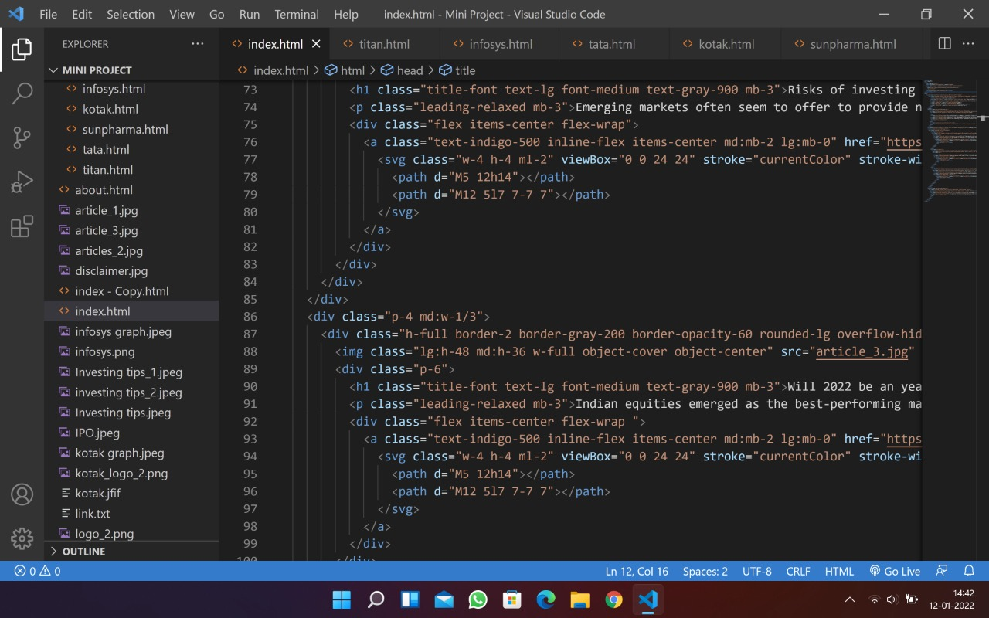

Fig 4.4: Home page code part 4

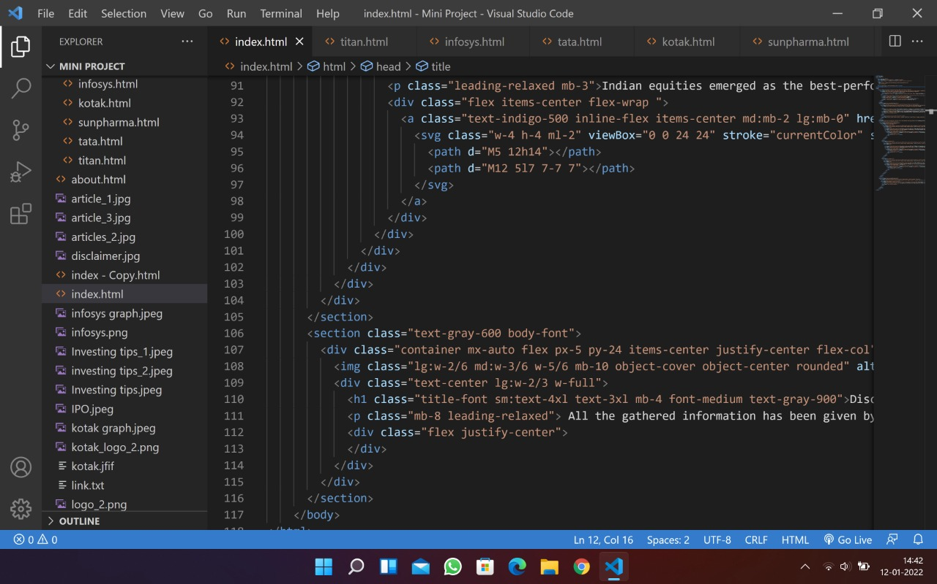

Fig 4.5: Home page code part 5

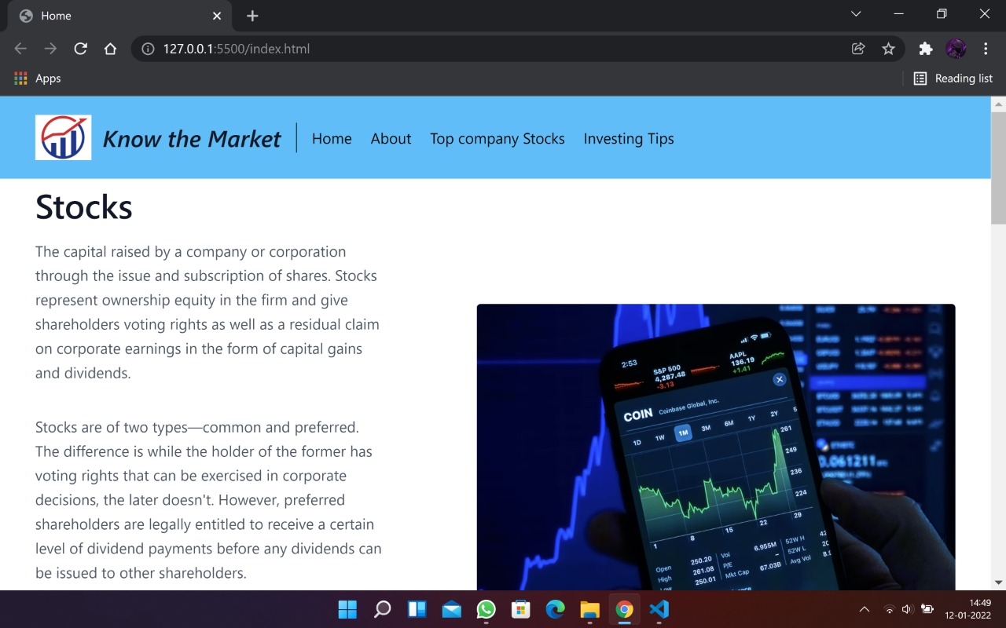

Fig 4.6: Home page output

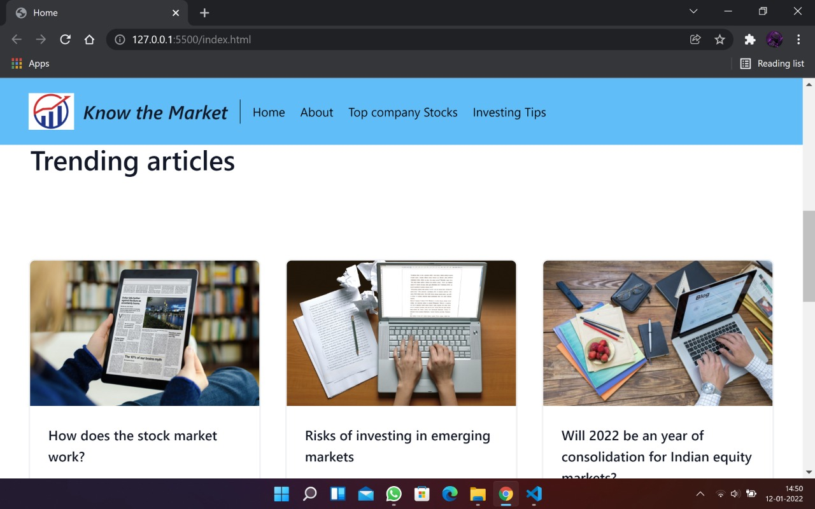

Fig 4.6: Home page output

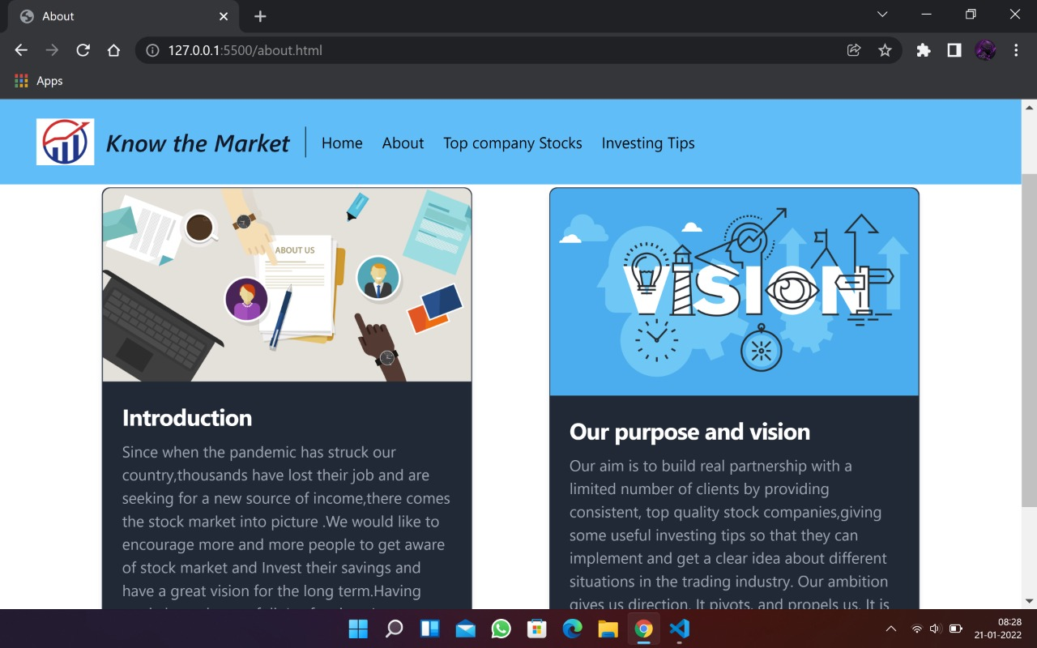

Fig 4.7: About us page output

**Second Page**

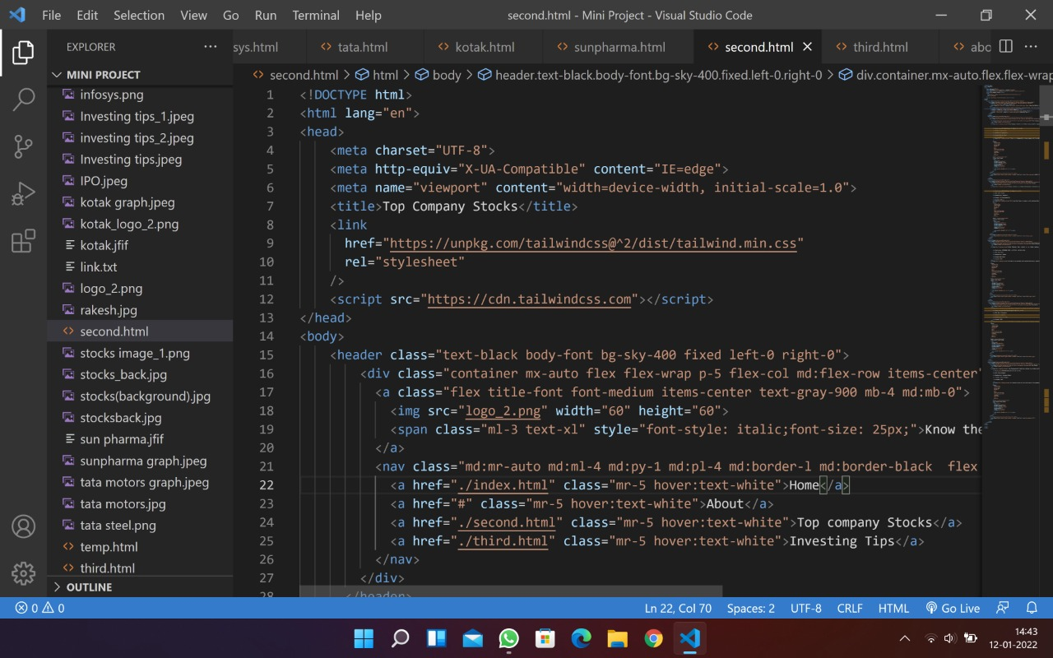

Fig 4.8: Second page code part

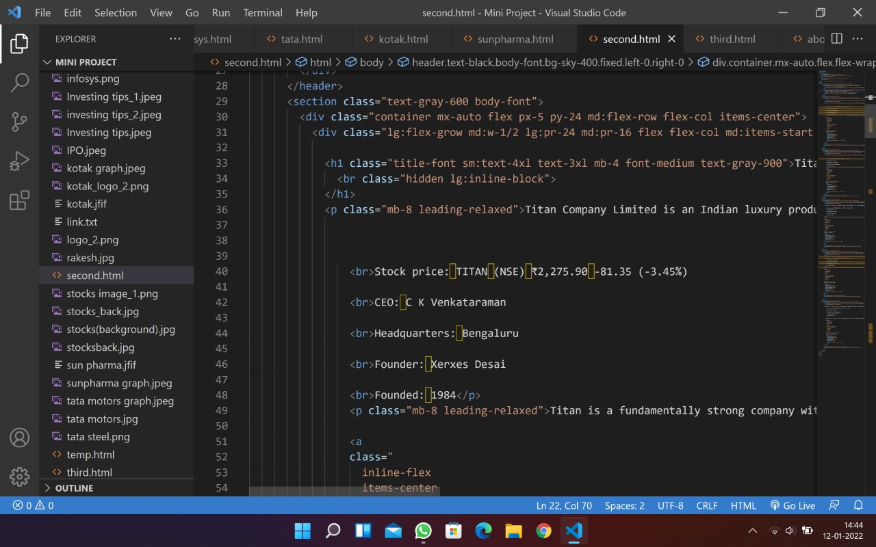

Fig 4.9: Titan stock code

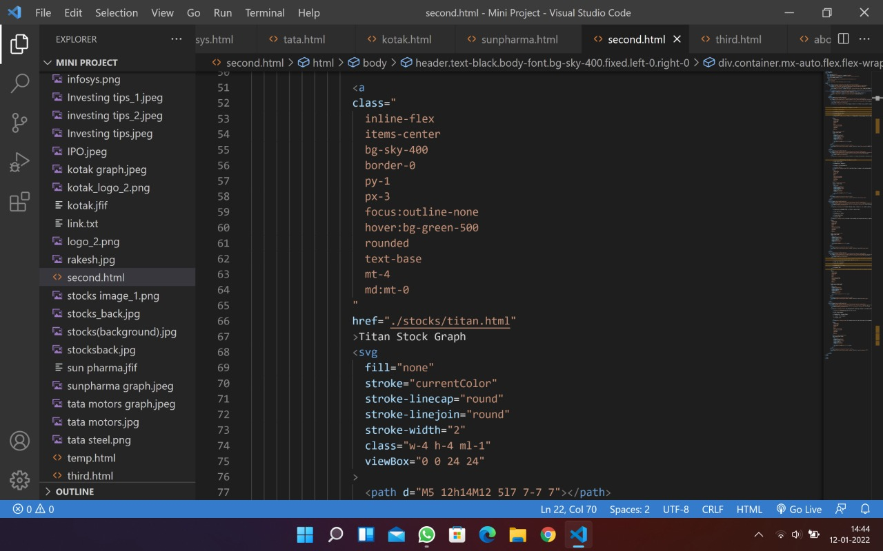

Fig 4.10: Titan stock graph

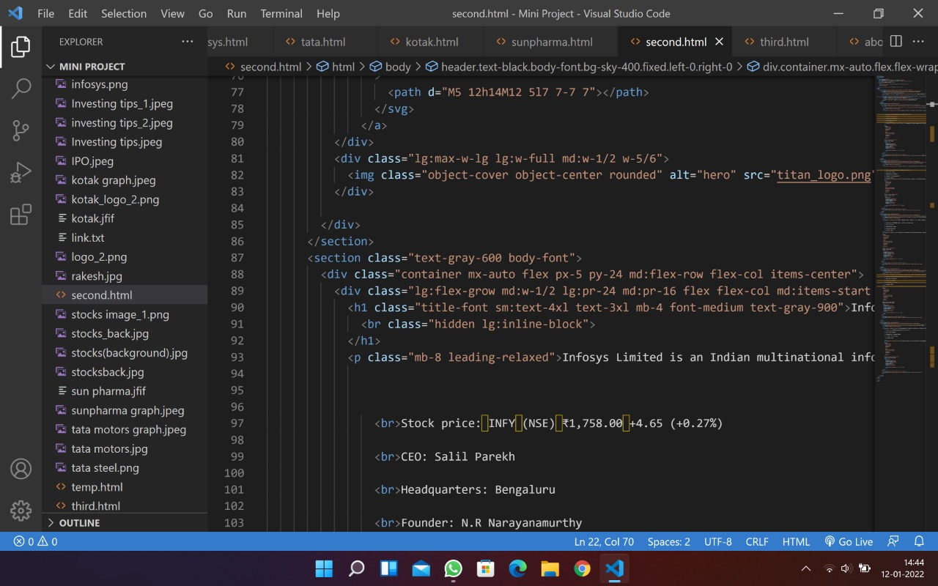

Fig 4.11: Infosys stock code

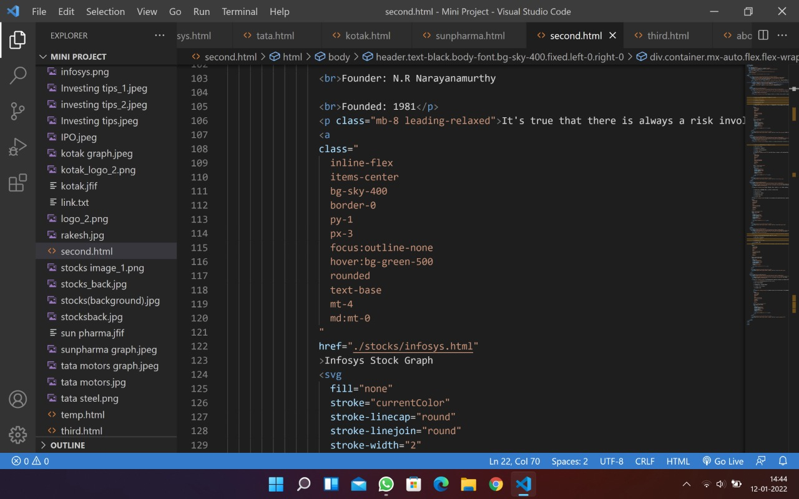

**Fig** 4.12: Infosys stock graph

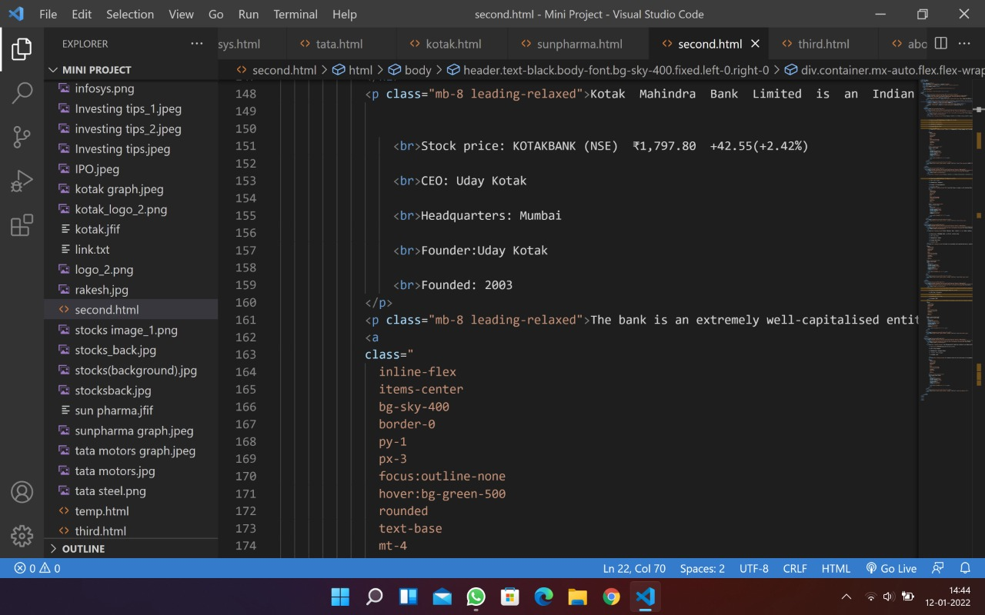

Fig 4.13: Kotak bank stock code

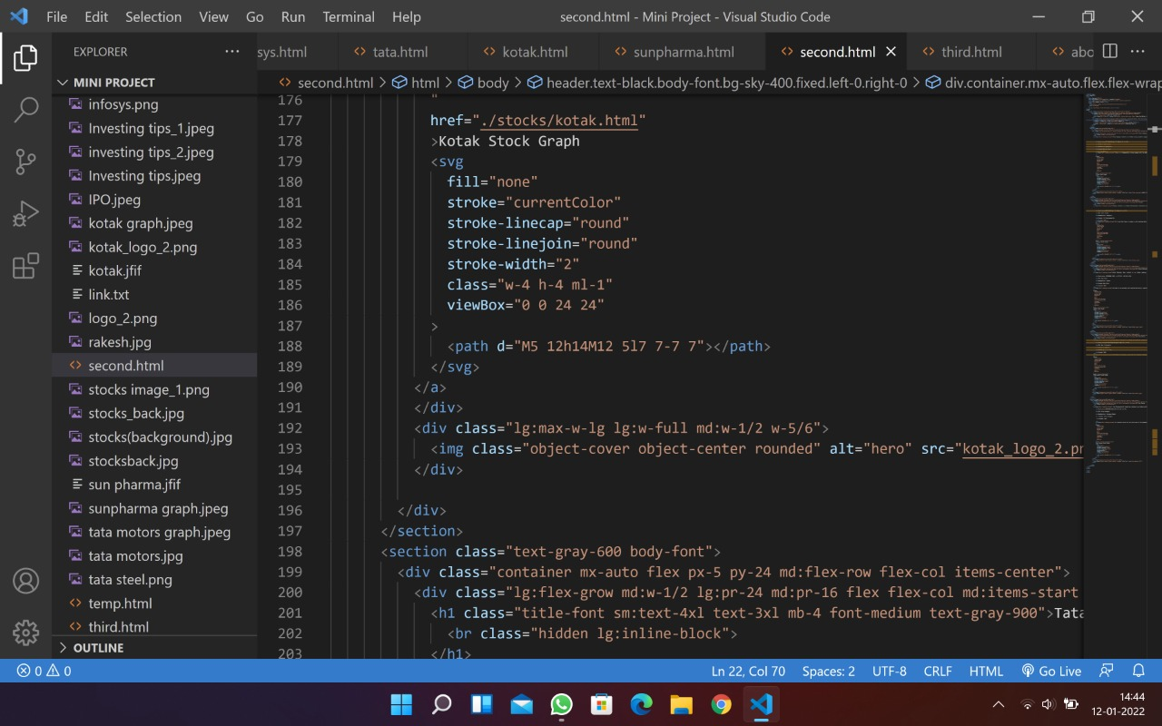

Fig 4.14: Kotak bank stock graph

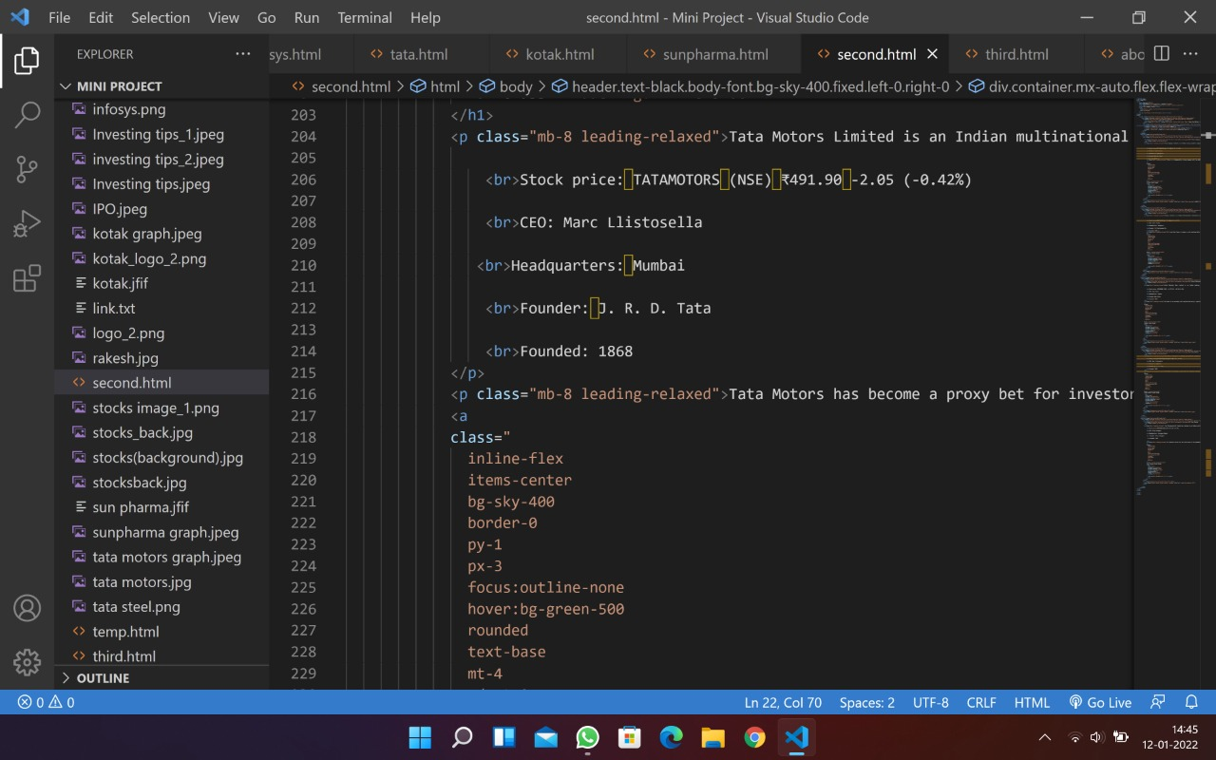

Fig 4.15: Tata motors stock code

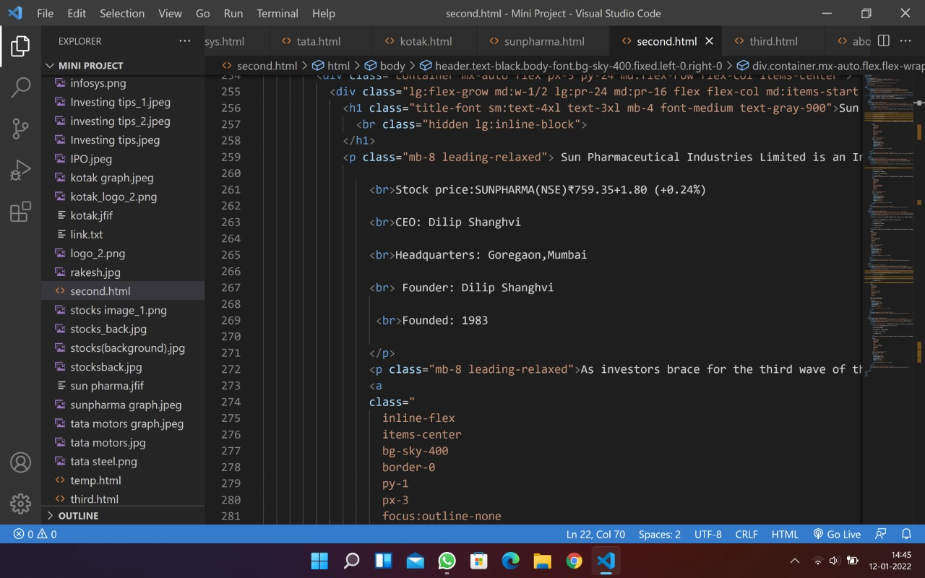

Fig 4.16: Sun pharma stock code

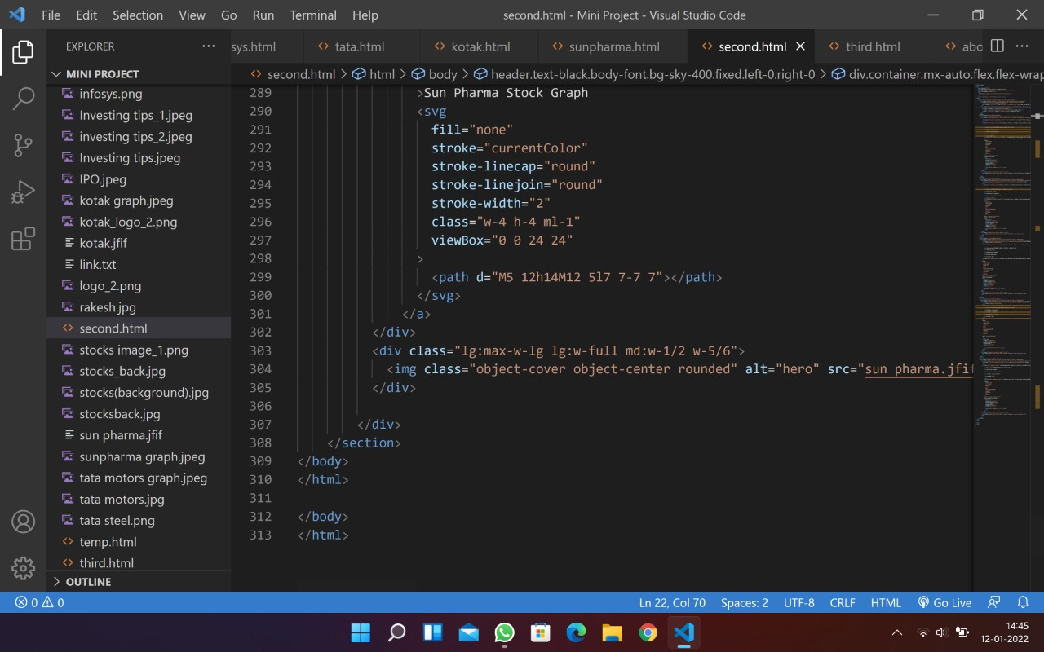

Fig 4.17: Sun pharma stock graph

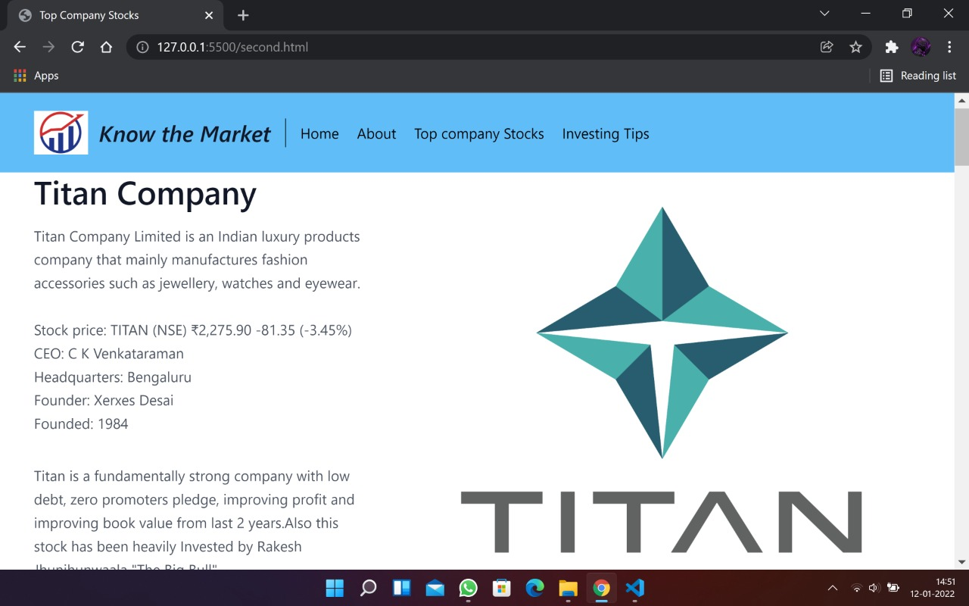

Fig 4.18: Titan stock output

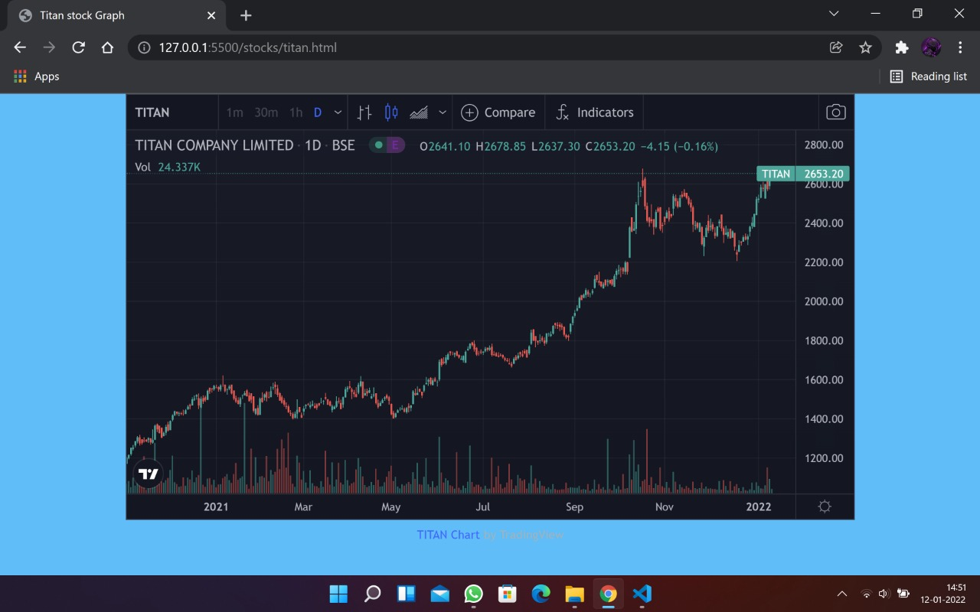

Fig 4.19: Titan stock graph output

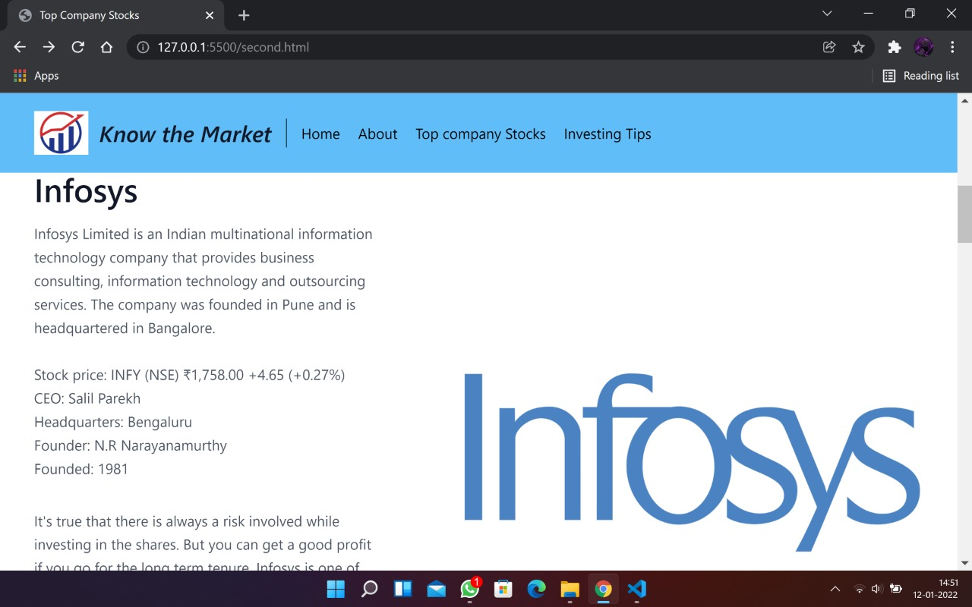

Fig 4.20: Infosys stock output

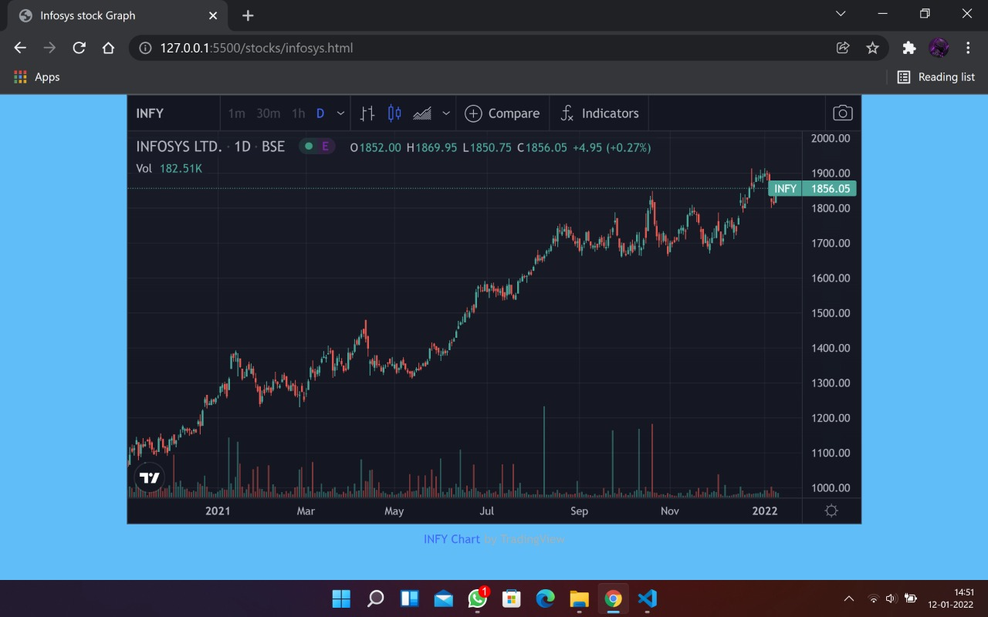

Fig 4.21: Infosys stock graph output

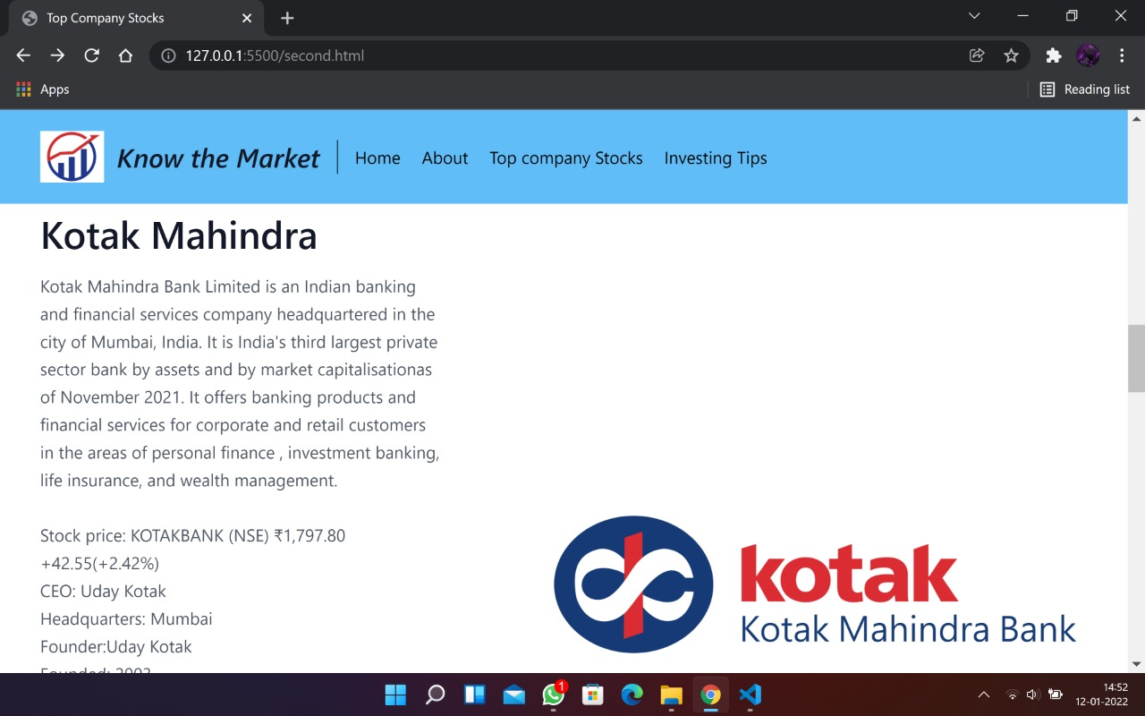

Fig 4.22: Kotak bank stock output

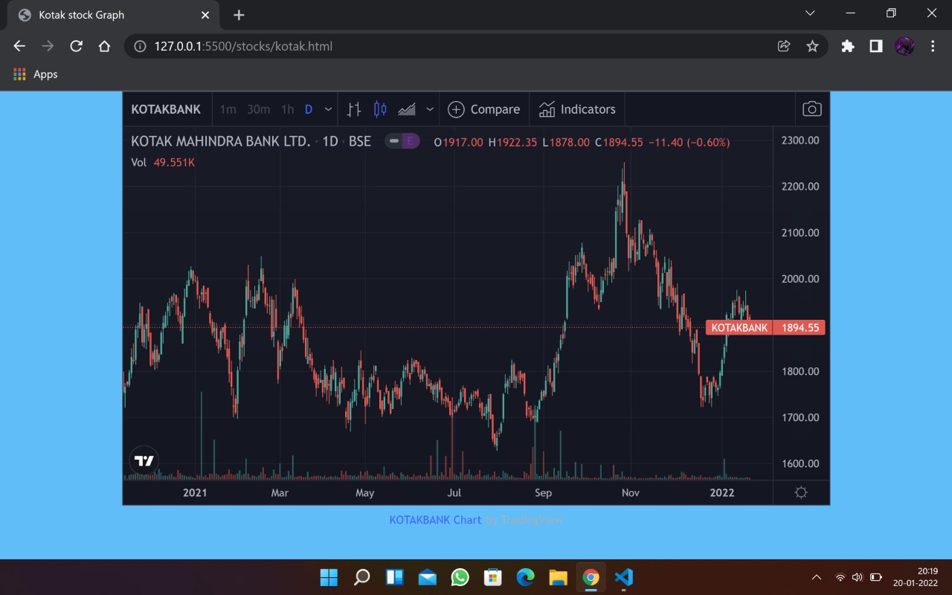

Fig 4.23: Kotak bank stock graph output

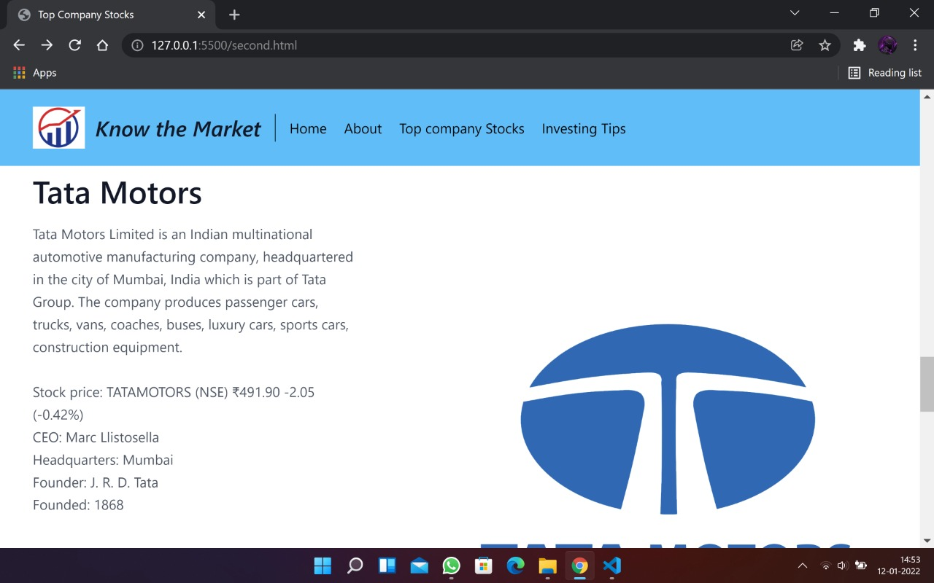

Fig 4.24: Tata motors stock output

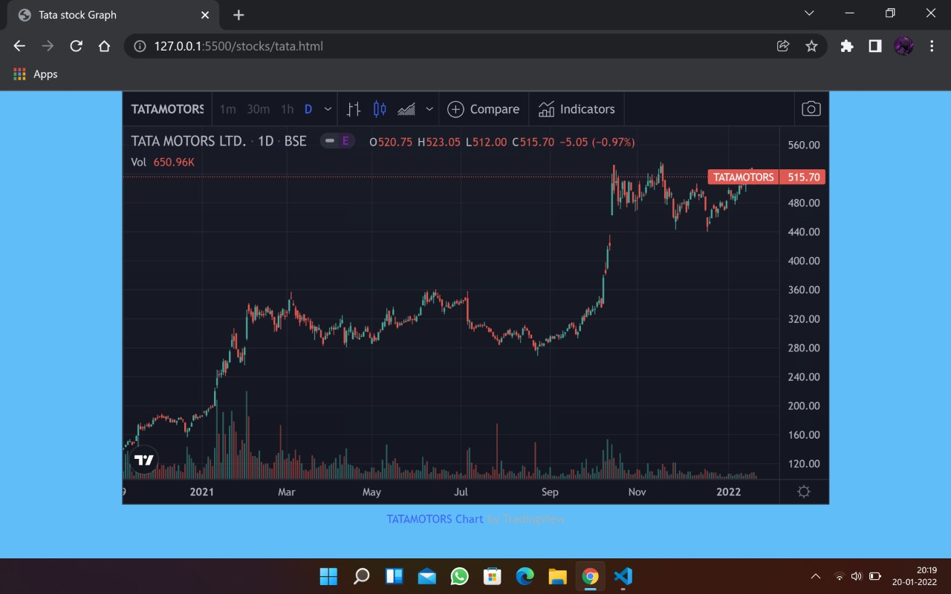

Fig 4.25: Tata motors stock graph

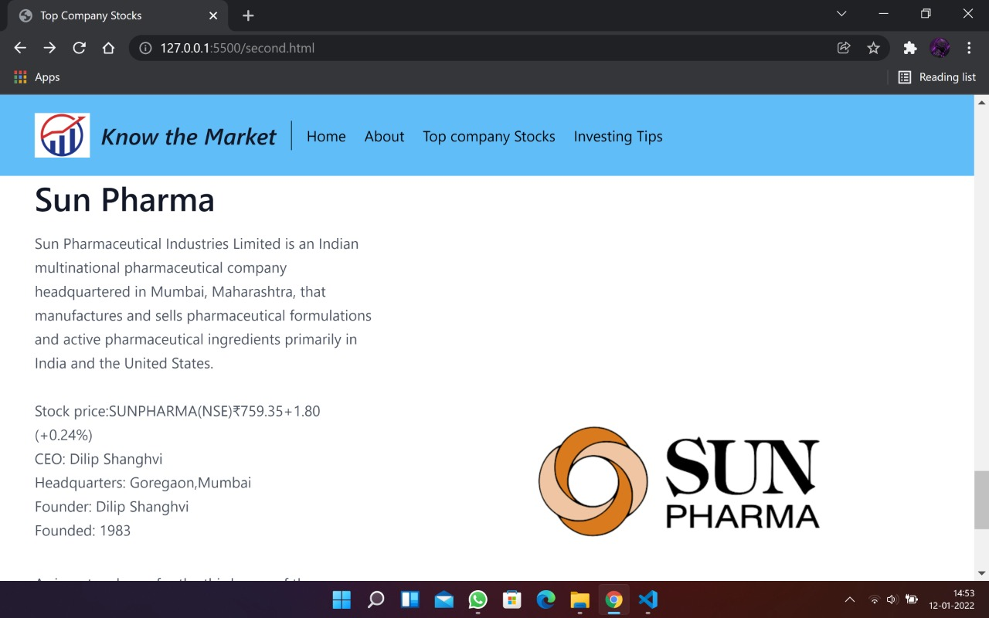

Fig 4.26: Sun pharma stock output

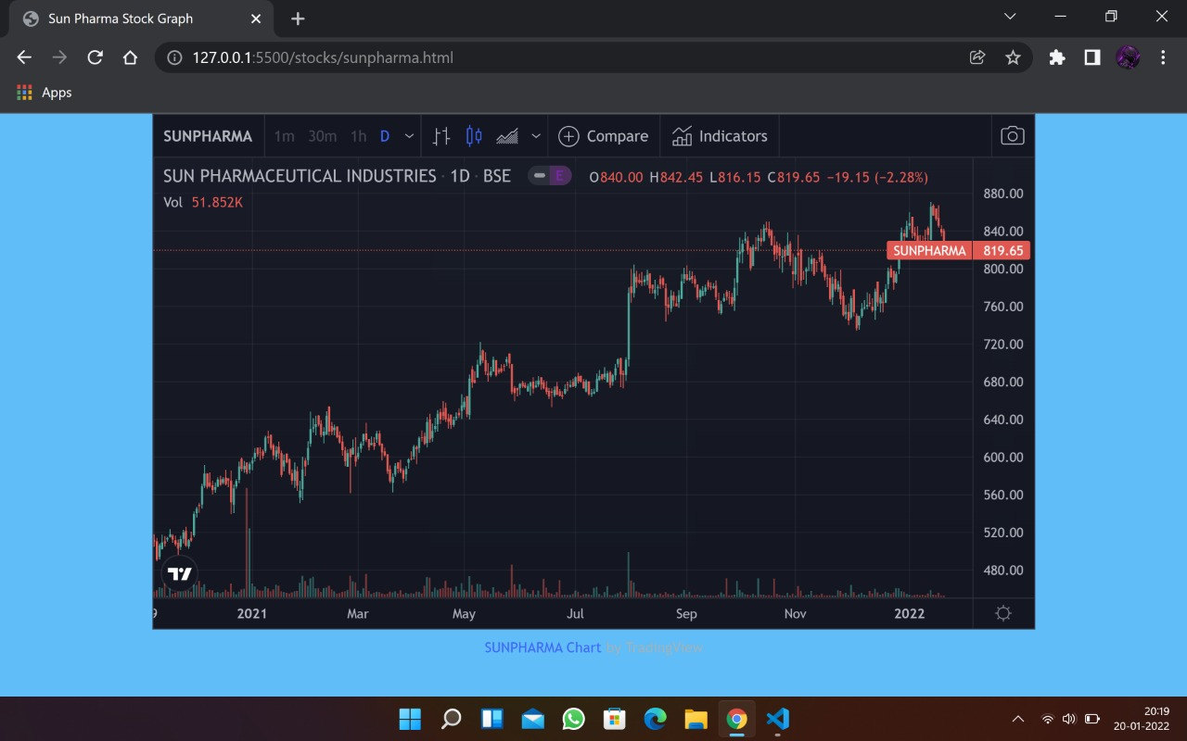

Fig 4.27: Sun pharma stock graph

**Third Page:**

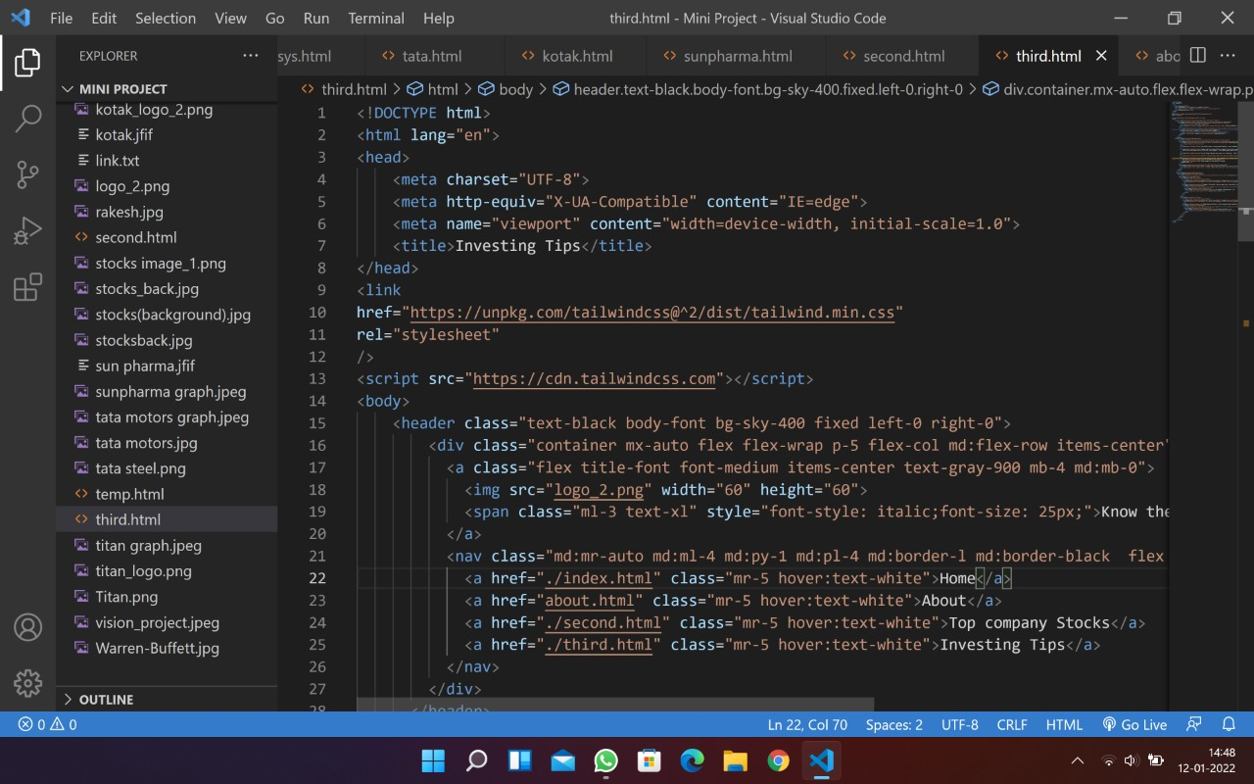

Fig4.28: Investing tips page code part1

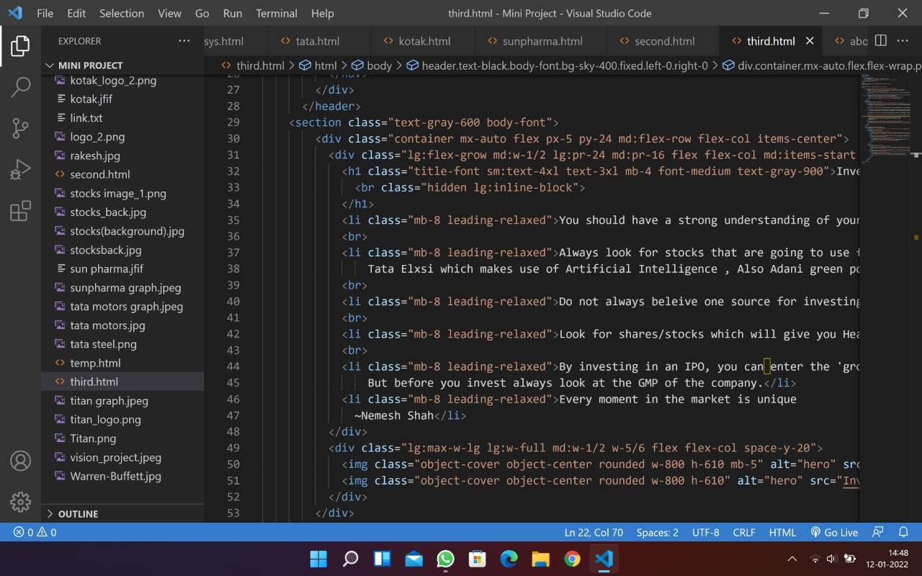

**Fig4.29: Investing tips page code part 2**

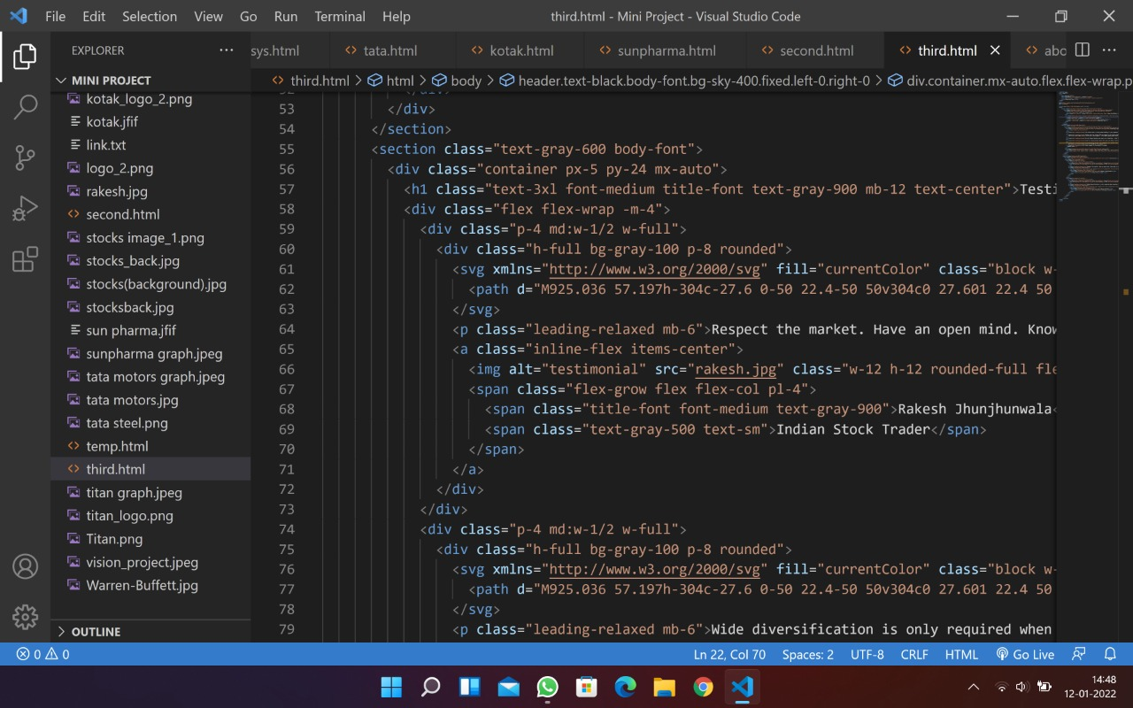

Fig 4.30: Investing tips page code part 4

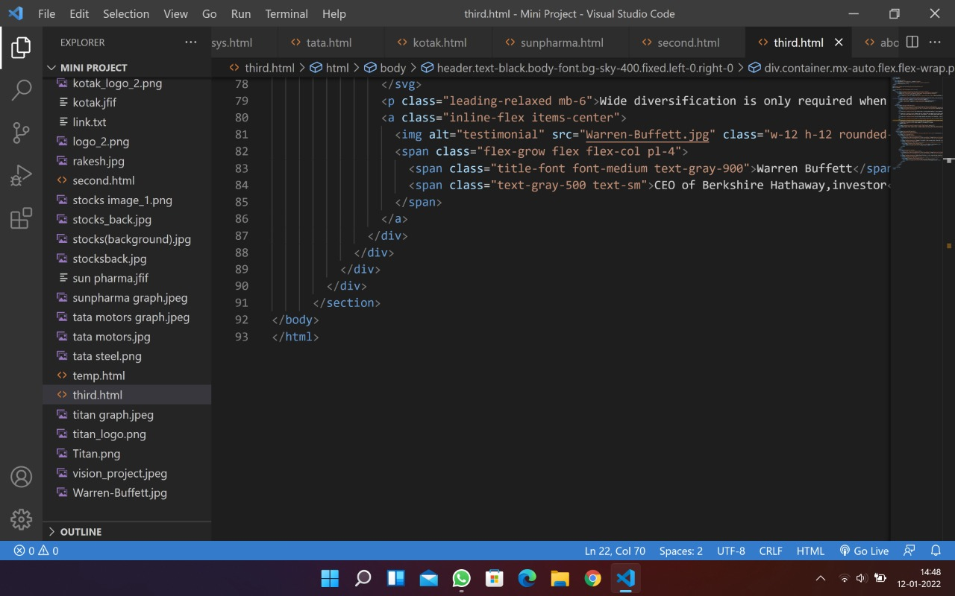

Fig 4.31: Investing tips page code part 5

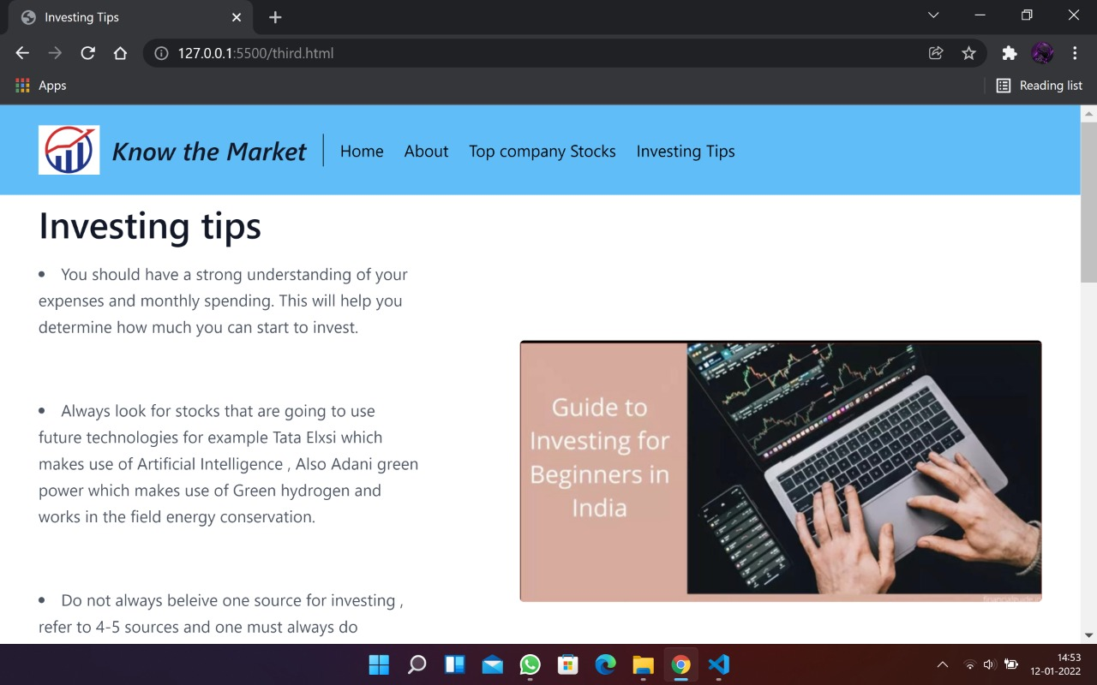

Fig 4.32: Investing tips page output

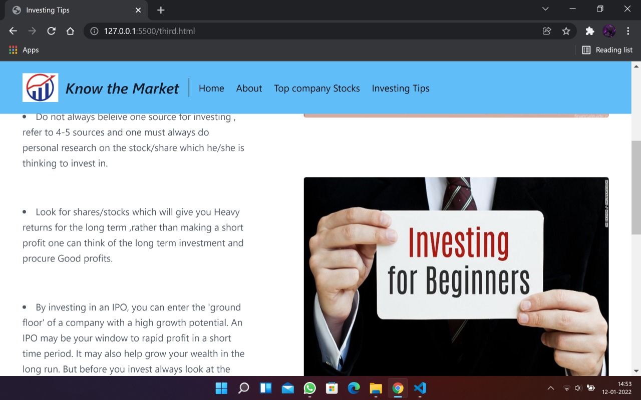

Fig 4.33: Investing tips page output

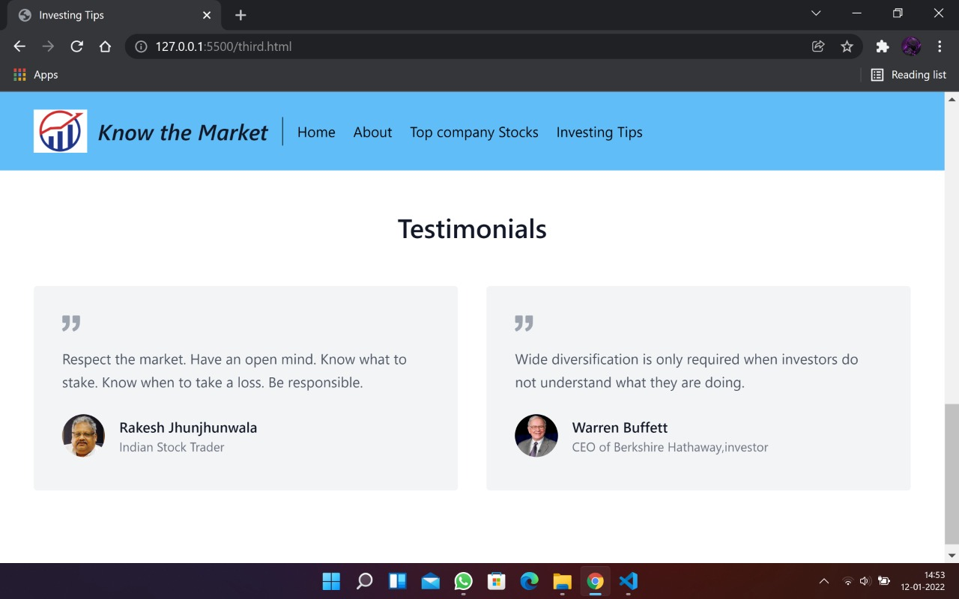

Fig 4.34: Investing tips page output

#### 5. CONCLUSION AND FUTURE SCOPE

It is a known fact that stock market is something which can change fortune of any person overnight if invested correctly. What is the importance of the stock market?

Stock markets are vital components of a free-market economy because they enable democratized access to trading and exchange of capital for investors of all kinds. They perform several functions in markets, including efficient price discovery and efficient dealing. Through our project we aim at drawing attention of the youth who are yet to begin their earning , we aim to provide tips such as when to invest and also giving knowledge about what exactly to see when thinking to apply for an IPO.

Having stock in a company means you are an owner. How many shares of stock you have determines the extent of that ownership. As part owner, you receive dividends and have voting rights. Stocks are volatile. Prices change according to supply and demand. Many people have different opinions on why stock prices move the way they do. One of the most important factors that influence prices is earnings.

Talking about future scope of our project, so far we have developed basic version of stock market website which aims at providing knowledge, various other features that can be included in our project are:

1. Adding complete list of stocks from all sectors
2. Providing feature to start a portfolio
3. Trading with live market rates
4. Giving complete financial information about all companies.

#### 6.BIBLIOGRAPHY

* https://www.w3schools.com/css/
* <https://www.w3schools.com/html/html_table_styling.asp>
* <https://www.w3schools.com/js/>
* <https://www.moneycontrol.com/>
* <https://economictimes.indiatimes.com/>
* <https://www.thehindubusinessline.com/>
* <https://www.bseindia.com/>
* <https://www.nseindia.com/>
* https://www.ipowatch.in/p/ipo-grey-market-premium-latest-ipo-grey.html